What?
Between June 22 and June 25, 2020, Head Football Coach Lonnie Cox and Union Pines High School football staff and players will host a youth football camp from 8:30 AM to 11:00 AM each day.

Who’s invited?
Children in grades Kindergarten through 6th grade will be allowed to attend.

What’s the cost?
The cost of the camp is $40.00 and that will cover all four days of the camp. A drink and snack will be provided each day of the camp. Checks can be made payable to Union Pines High Football. You will also be allowed to pay on the opening morning of the camp. There will be a table set up in the meeting room, which is located in the field house, where someone will be taking up checks/money.

What will your kids do?
Your child will be taught the basic fundamentals and techniques related to football. This will translate into their performances at all levels and ensure safety. Moreover, your child will be given the opportunity to compete in fun competitions and games against their peers, which will make the camp even more enjoyable.

T-Shirt Size

Your child will be provided with a camp T-shirt on the concluding day of the camp. Please make sure that you write a number in the appropriate box below in order to ensure that your child receives the correct size. If your child wears a youth small, for example, you would write “1” beside Youth Small in the box. You and your family will also be able to purchase a camp T-shirt for an additional cost of $10.00 per shirt. Make sure the appropriate number is placed beside the correct size(s).

YOUTH SMALL
YOUTH MEDIUM
YOUTH LARGE
YOUTH X-LARGE
ADULT SMALL
ADULT MEDIUM
ADULT LARGE
ADULT X-LARGE
ADULT XX-LARGE
ADULT XXX-LARGE
ADULT XXXX-LARGE

CAMP ATTENDEE INFORMATION

CAMP ATTENDEE
PARENTS NAME
CHECK OR CASH
MEDICAL ISSUES

Union Pines High School
Home Of The Vikings
Youth Football Camp 2020

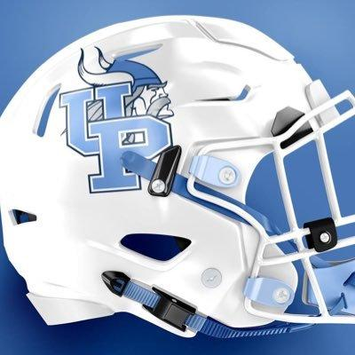

Payable Mailing Address

To The Attention Of: Coach Cox
1981 Union Church Road
Cameron, North Carolina 28326

Camp Contact Information
Coach Lonnie Cox
Head Football Coach
910-947-5511
lrcox@ncmcs.org

